**ASSIGNMENT**

# Objective:

This exam aims to assess students' knowledge and skills in ReactJS after completing the course. The objective of the exam is to evaluate students' ability to use ReactJS to build a simple web application and understand the basic concepts and functionalities of ReactJS.

# Testing Skills:

* Understanding the concepts and usage of ReactJS components.
* Handling state and props in ReactJS.
* Using ReactJS lifecycle methods.
* Creating and managing forms in ReactJS.
* Using React Router for navigation in ReactJS applications.

# Guidelines:

## Activity 1: Building a Simple ReactJS Application to Display a Product List from an API (3 points)

In this activity, you are required to build a ReactJS application that retrieves data from an API and displays a product list on the interface. You can use either the fetch or axios library to make the API request.

* Use fetch or axios to retrieve data from the API.
* Display the product list on the interface.
* Handle errors when unable to fetch data from the API.

Here are the steps to follow:

* Set up a new ReactJS project using your preferred development environment.
* Create a new component called "**ProductList**" that will be responsible for fetching the data from the API and displaying the product list.
* In the "ProductList" component, use the **fetch** or **axios** library to make a GET request to the API endpoint that returns the product data.
* Handle any errors that may occur during the API request and display an appropriate error message if necessary.
* Once the data is successfully fetched, store it in the component's state.
* Render the product list on the interface using the data from the state.

Remember to structure your components and files properly, following best practices for ReactJS development. Use functional components and hooks whenever possible.

REST API Examples: Products.json

{

  "products": [

    {

      "id": "1",

      "name": " Laptop LG Gram 2023 14ZD90R-G.AX52A5",

      "description": "Intel core i5-1340P, Ram 8GB, SSD 256GB, Màn Hình 14 inch WUXGA, Siêu mỏng, siêu nhẹ",

      "price": "25.990.000",

      "currentPrice": "20.990.000",

      "image": "laptop1.png"

    },

    {

      "id": "2",

      "name": "Laptop ACER Aspire 3 A315-59-51X8",

      "description": "Intel Core i5-1235U, Ram 8GB, SSD 512GB, màn hình 15.6 inch FHD, Win 11 bản quyền, màu bạc, chính hãng, bảo hành 12 tháng",

      "price": "17.990.000",

      "currentPrice": "11.990.000",

      "image": "laptop2.jpg"

    },

    {

      "id": "3",

      "name": "Laptop Dell Vostro 5630 i5P085W11GRU",

      "description": "Intel i5-1340P, Ram 8GB DDR5, SSD 512GB, Màn Hình 16 Inch FHD+, VGA Intel Iris Xe, Windows 11 Home, Office HS 2021 bản quyền, vỏ nhôm",

      "price": "23.190.000",

      "currentPrice": "19.990.000",

      "image": "laptop3.png"

    },

    {

      "id": "4",

      "name": "Laptop MSI Katana 15 B13VEK-252VN",

      "description": "i7-13620H, Ram 8GB, SSD 512GB, màn hình 15.6inch FHD 144Hz, VGA 4050 6GB, Win 11 bản quyền, bảo hành 24 tháng.",

      "price": "24.990.000",

      "currentPrice": "22.990.000",

      "image": "laptop4.png"

    },

    {

      "id": "5",

      "name": "Laptop ASUS TUF Gaming F15 FX507ZC4-HN099W",

      "description": "i7-12700H, Ram 8GB, SSD 512GB, RTX 3050 4GB, Màn hình 15.6 FHD 144Hz IPS, Win 11, Hàng chính hãng, Bảo hành 24 tháng.",

      "price": "26.990.000",

      "currentPrice": "23.490.000",

      "image": "laptop5.jpg"

    },

    {

      "id": "6",

      "name": "LAPTOP ASUS VIVOBOOK A1505VA-L1114W",

      "description": "Core i5 13500H, Ram 16GB, 512GB SSD, màn hình 15.6inch FHD OLED, Windows 11 Home bản quyền, màu đen.",

      "price": "20.990.000",

      "currentPrice": "17.190.000",

      "image": "laptop6.png"

    },

    {

      "id": "7",

      "name": "Laptop Acer Predator Helios Neo PHN16-71-7460",

      "description": "Intel i7-13700HX, RAM 8GB, SSD 512GB, RTX 4050 6GB, Màn Hình 16inch QHD 165Hz 100% sRGB, Windows 11",

      "price": "38.990.000",

      "currentPrice": "38.490.000",

      "image": "laptop7.jpg"

    },

    {

      "id": "8",

      "name": "Laptop MSI Modern 14 C7M 220VN",

      "description": "AMD R5 7530U, Ram 8GB, SSD 512GB, Màn Hình 14.0inch FHD IPS, Windows 11, Đen",

      "price": "12.990.000",

      "currentPrice": "10.990.000",

      "image": "laptop8.jpg"

    },

    {

      "id": "9",

      "name": "Laptop Gaming Acer Nitro 5 Tiger AN515-58-773Y",

      "description": "i7-12700H, Ram 8GB, SSD 512GB, RTX 3050Ti 4GB, 15.6 inch FHD, Windows 11",

      "price": "31.990.000",

      "currentPrice": "25.490.000",

      "image": "laptop9.png"

    },

    {

      "id": "10",

      "name": "Laptop Acer Swift 3 SF314-512-56QN",

      "description": "Core i5-1240P, Ram 16GB, SSD 512GB, màn hình 14 inch QHD IPS, Win 11bản quyền, màu bạc",

      "price": "21.990.000",

      "currentPrice": "17.490.000",

      "image": "laptop10.png"

    }

  ]

}

The results are shown below:

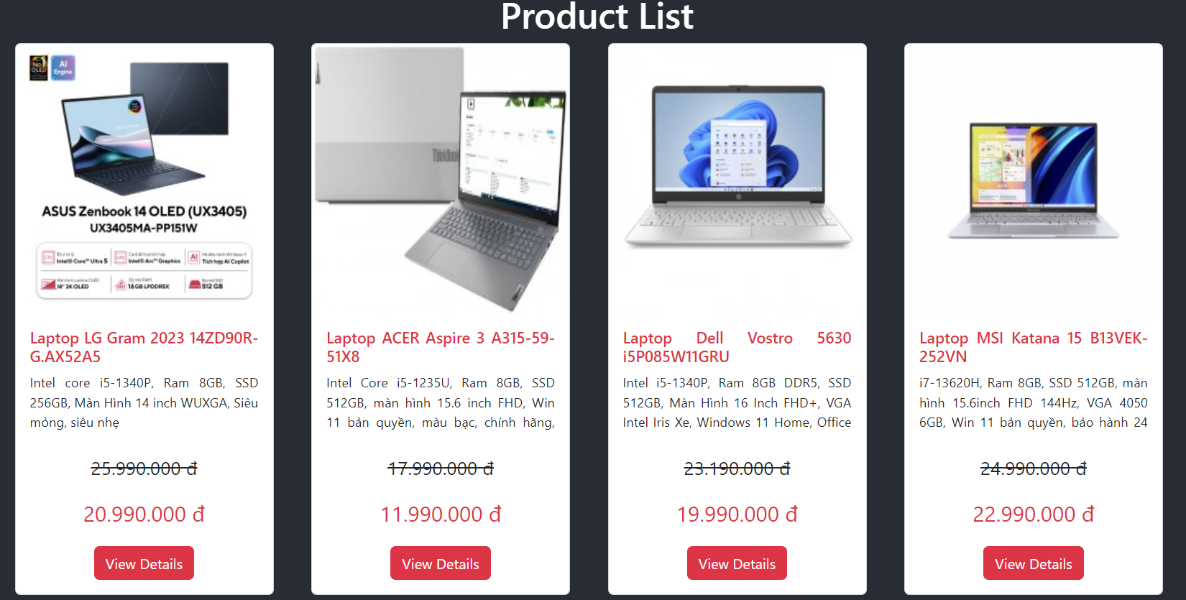

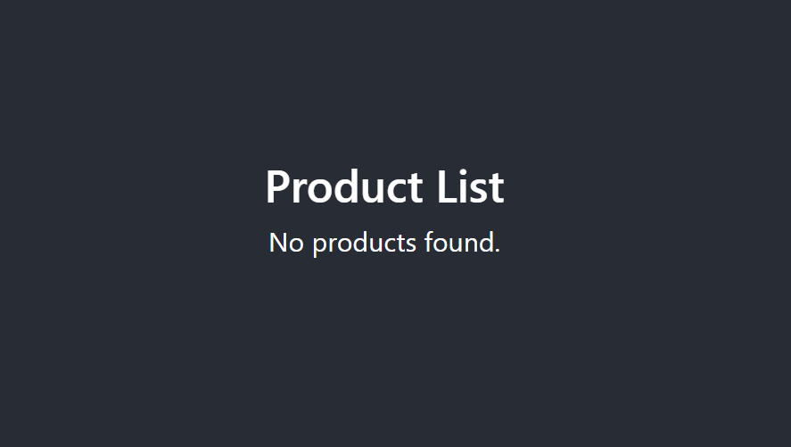

## Activity 2: Implementing the Functionality to Add and Delete Products from the List (3 points)

In this activity, you will enhance this application by adding the functionality to add and delete products from the product list.

* Add the functionality to add a new product to the list.
* Add the functionality to delete a product from the list.

Here are the steps to follow:

* Modify the "ProductList" component to include a form for adding new products. The form should have fields for the product name, description, price and currentPrice.
* Implement the functionality to handle form submission. When the user submits the form, create a new product object with the entered values and add it to the product list. Update the component's state accordingly.
* Display the updated product list on the interface, including the newly added product.
* Implement the functionality to delete a product from the list. Add a delete button next to each product in the list. When the user clicks the delete button, remove the corresponding product from the list and update the component's state.
* Update the product list on the interface to reflect the changes.

Remember to handle the state appropriately and update it accordingly when adding or deleting products. Consider using unique identifiers for each product to ensure accurate deletion.

The results are shown below:

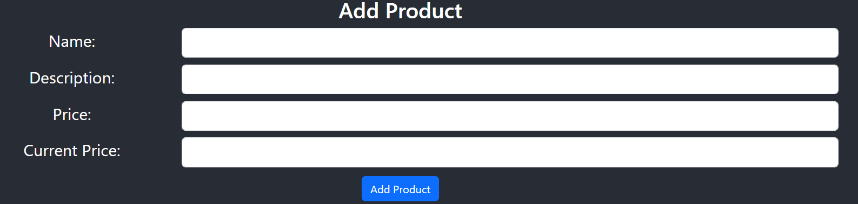

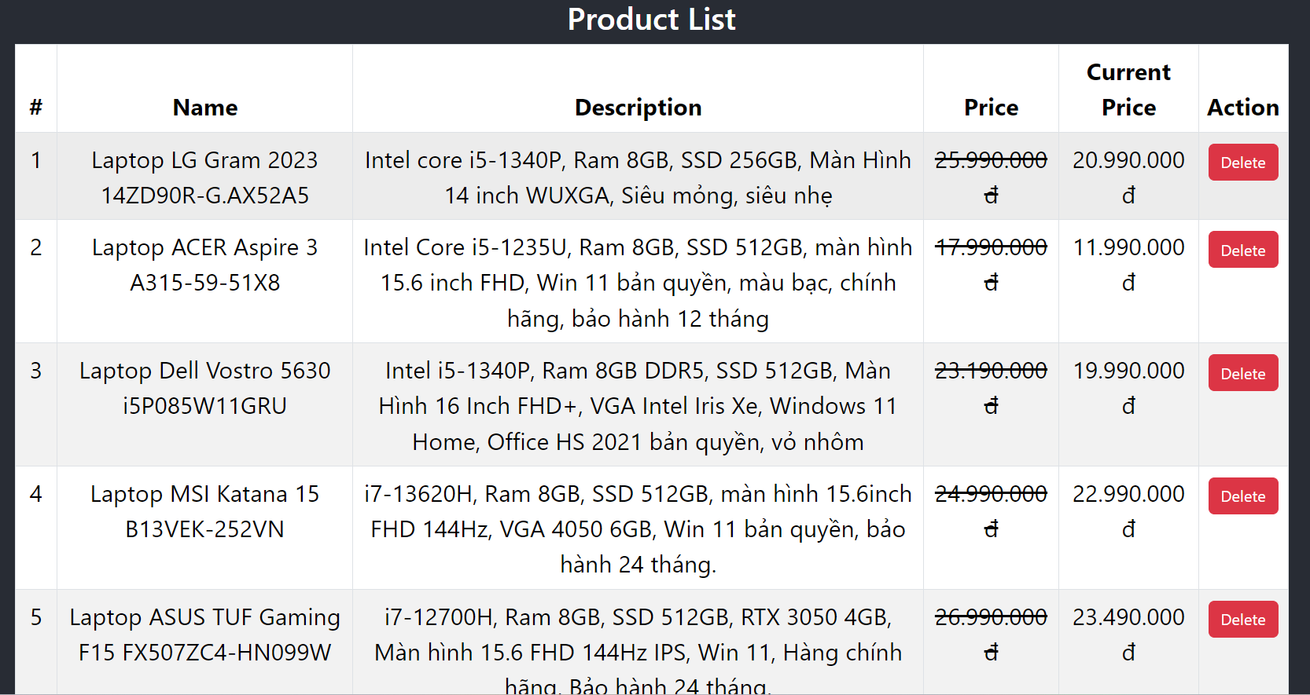

## Activity 3: Creating a Product Detail Page and Implementing the Edit Product Functionality (2 points)

In this activity, you will create a product detail page to display detailed information about a specific product. Additionally, you will implement the functionality to edit the product information.

* Create a product detail page to display detailed information about a product.
* Implement the functionality to edit the product information.

Here are the steps to follow:

* Create a new component called "ProductDetail" that will be responsible for displaying the detailed information of a single product.
* Modify the "ProductList" component to include a link or button for each product that navigates to the corresponding product detail page.
* In the "ProductDetail" component, retrieve the product's information from the API based on the product ID passed as a parameter or stored in the component's state.
* Display the product's information on the product detail page, including the product name, description, and price.
* Implement the functionality to edit the product information. Add an "Edit" button on the product detail page. When theuser clicks the "Edit" button, navigate to a separate page or modal where the user can modify the product details.
* Implement the necessary form and functionality to update the product information. When the user submits the updated details, make a PUT request to the API to update the product's information.
* Handle any errors that may occur during the update process and display an appropriate error message if necessary.
* Once the product information is successfully updated, navigate back to the product detail page and display the updated details.

Remember to handle the state and navigation appropriately. Consider using React Router to implement the navigation between the product list, product detail, and edit product pages.

The results are shown below:

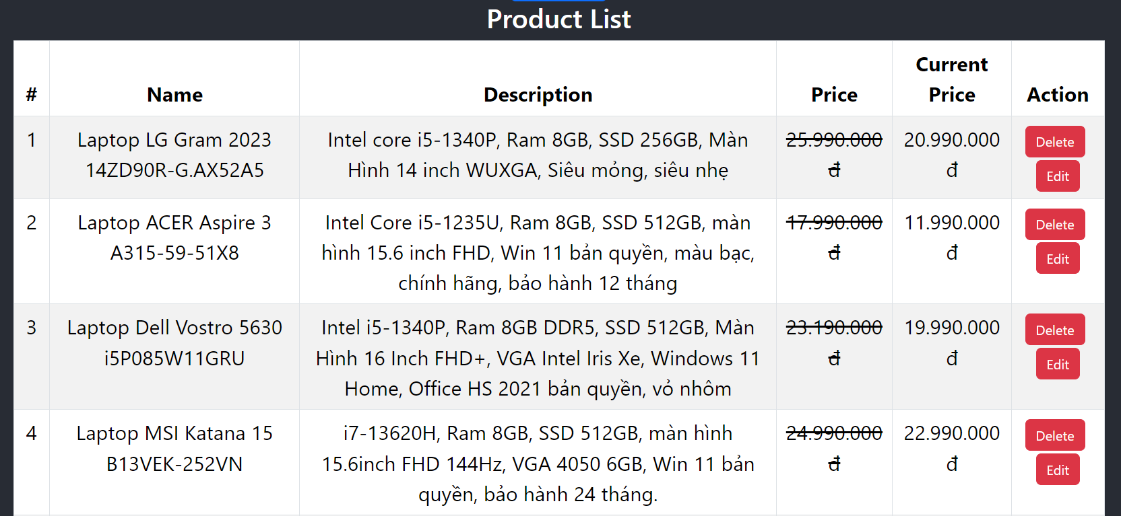

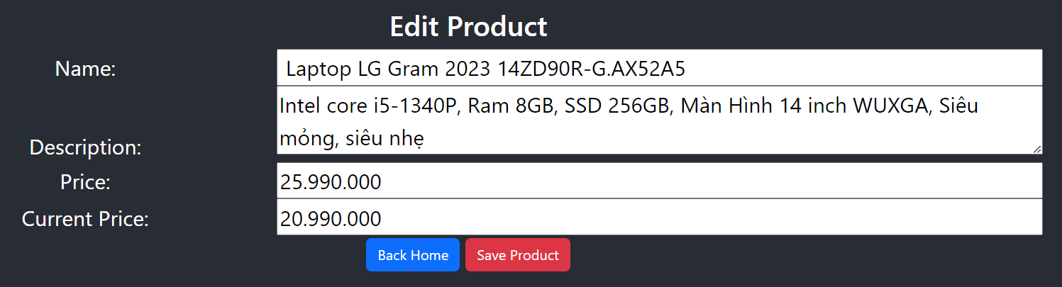

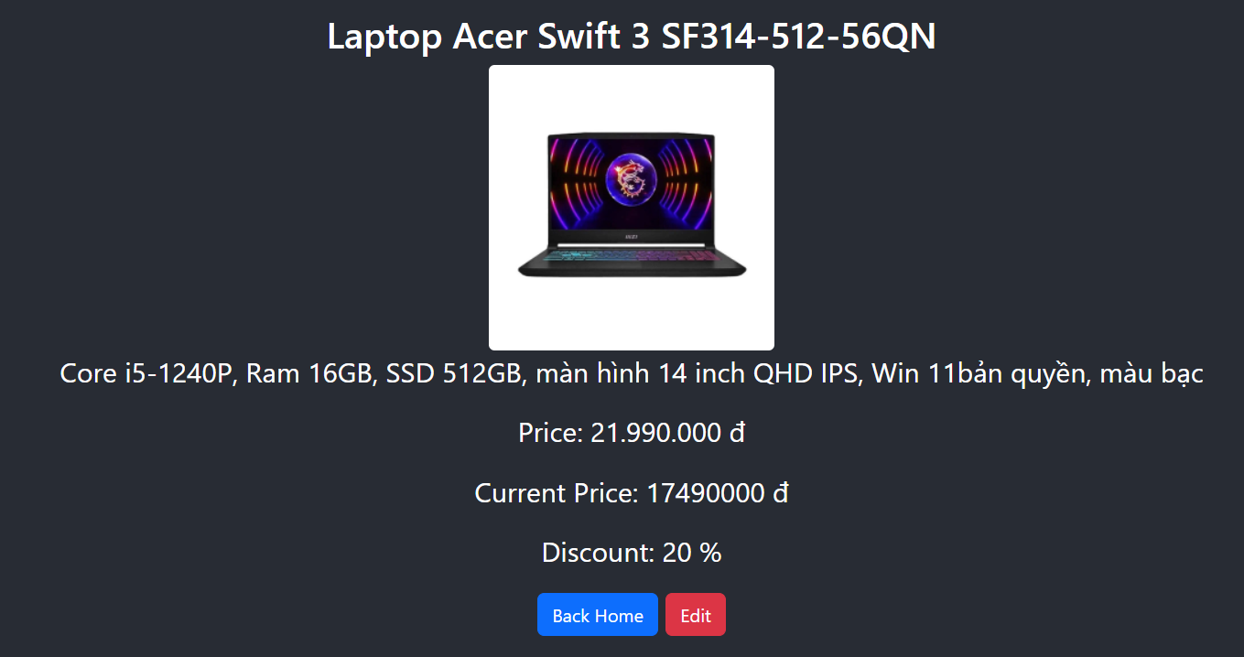

Product detail page interface

# Conclusion:

This exam aims to evaluate students' ability to use ReactJS to build a simple web application. Students will be tested on their understanding of the basic concepts of ReactJS, their ability to handle state and props, use lifecycle methods, create and manage forms, and use React Router for navigation in ReactJS applications.

Note: The use of Redux, Redux Thunk, and Redux Toolkit will earn an additional 2 points